IMS Engineering College, Ghaziabad



Resume Builder

**Subject Name: Mini project**

**Subject Code: KCS-354**

COURSE: B.Tech.

SEMESTER: 3

**by**

Prateekshit Jaiswal (2101430100130)

# Department of Computer Science and Engineering IMS ENGINEERING COLLEGE

**NH-09, Adhyatmik Nagar, Ghaziabad-201015 (2022-23)**

# Vision and Mission of the Institute and Department

#### Vision of the Institute

“To make IMSEC an Institution of Excellence for empowering students through technical education coupled with incorporating values and developing engineering acumen for innovations and leadership skills for the betterment of society.”

#### Mission of the Institute

* To promote academic excellence by continuous learning in core and emerging Engineering areas using innovative teaching and learning methodologies.
* To inculcate values and ethics among the learners.
* To promote industry interactions and produce young entrepreneurs.
* To create a conducive learning and research environment for life-long learning to develop the students as technology leaders and entrepreneurs for addressing societal needs.

#### Vision of the Department

To provide globally competent professionals in the field of Computer Science & Engineering embedded with sound technical knowledge, aptitude for research and innovation with ethical values to cater to the industrial & societal needs.

#### Mission of the Department

M1: To provide quality undergraduate education in both the theoretical & applied foundations of Computer Science Engineering.

M2: Conduct research to advance the state of the art in Computer Science & Engineering and integrate the research results as innovations.

M3: To inculcate team building skills and promote life-long learning with high societal and ethical values**.**

**Program Outcomes (POs)**

|  |  |
| --- | --- |
| **S. No.** | **Program Outcomes / Program Specific Outcomes** |
| **PO1.** | **Engineering knowledge**: Apply the knowledge of mathematics, science, engineering fundamentals, and an engineering specialization to the solution of complex engineering problems. |
| **PO2.** | **Problem analysis:** Identify, formulate, review research literature, and analyze complex  engineering problems reaching substantiated conclusions using first principles of mathematics, natural sciences, and engineering sciences. |
| **PO3.** | **Design/development of solutions:** Design solutions for complex engineering problems and design system components or processes that meet the specified needs with appropriate  consideration for the public health and safety, and the cultural, societal, and environmental considerations. |
| **PO4.** | **Conduct investigations of complex problems:** Use research-based knowledge and  research methods including design of experiments, analysis and interpretation of data, and synthesis of the information to provide valid conclusions. |
| **PO5.** | **Modern tool usage:** Create, select, and apply appropriate techniques, resources, and  modern engineering and IT tools including prediction and modelling to complex engineering activities with an understanding of the limitations. |
| **PO6.** | **The engineer and society:** apply reasoning informed by the contextual knowledge to assess  societal, health, safety, legal and cultural issues and the consequent responsibilities relevant to the professional engineering practice. |
| **PO7.** | **Environment and sustainability:** Understand the impact of the professional engineering  solutions in societal and environmental contexts, and demonstrate the knowledge of, and need for sustainable development. |
| **PO8.** | **Ethics:** Apply ethical principles and commit to professional ethics and responsibilities and norms of the engineering practice. |
| **PO9.** | **Individual and team work**: Function effectively as an individual, and as a member or leader in diverse teams, and in multidisciplinary settings. |
| **PO10.** | **Communication:** Communicate effectively on complex engineering activities with the engineering community and with society at large, such as, being able to comprehend and write  effective reports and design documentation, make effective presentations, and give and receive clear instructions. |
| **PO11.** | **Project management and finance:** Demonstrate knowledge and understanding of the  engineering and management principles and apply these to one’s own work, as a member and leader in a team, to manage projects and in multidisciplinary environments. |
| **PO12.** | **Life-long learning:** Recognize the need for, and have the preparation and ability to engage in independent and life-long learning in the broadest context of technological change. |

**Program Specific Outcomes (PSOs)**

PSO1: To apply standard software engineering practices & strategies in real-time software project development

PSO2: To apply latest programming languages in creating innovative career opportunities.

### Program Educational Objectives (PEOs)

Graduate Will:

PEO1: Possess knowledge to enable continued professional development. PEO2: Engage in life-long learning to foster personal & organization growth. PEO3: Work productively as successful professionals in diverse career paths.

PEO4: Effectively communicate ideas to promote collaboration in accordance with societal standards & ethical practices.

**Course Outcomes**

|  |  |  |
| --- | --- | --- |
| **CO. No.** | **DESCRIPTION** | **COGNITIVE LEVEL (BLOOMS**  **TAXONOMY)** |
| **CO1(C209.1)** | Developing a technical artifact requiring new technical  skills and effectively utilizing a new software tool to complete a task | **K4,K5** |
| **CO2(C209.2)** | Writing requirements documentation, Selecting  appropriate technologies, identifying and creating appropriate test cases for systems. | **K5,K6** |
| **CO3(C209.3)** | Demonstrating understanding of professional customs & practices and working with professional standards. | **K4,K5** |
| **CO4(C209.4)** | Improving problem-solving, critical thinking skills and report writing. | **K4,K5** |
| **CO5(C209.5)** | Learning professional skills like exercising leadership, behaving professionally, behaving ethically, listening effectively, participating as a member of a team, developing appropriate workplace attitudes | **K2,K4** |

**CO-PO-PSO Mapping**

|  |  |  |  |  |  |  |  |  |  |  |  |  |  |  |
| --- | --- | --- | --- | --- | --- | --- | --- | --- | --- | --- | --- | --- | --- | --- |
|  | **PO 1** | **P O2** | **PO 3** | **PO 4** | **PO 5** | **PO 6** | **PO 7** | **PO 8** | **PO 9** | **PO 10** | **PO 11** | **PO 12** | **PS O1** | **PSO 2** |
| **C209.1** | 3 | 3 | 3 | 3 | 3 | 2 | 1 | 2 | 2 | 2 | 2 | 3 | 3 | 3 |
| **C209.2** | 3 | 3 | 2 | 2 | 2 | 1 | 1 | 2 | 2 | 3 | 1 | 1 | 2 | 3 |
| **C209.3** | 1 | 1 | 1 | 1 | 1 | 3 | 2 | 3 | 2 | 2 | 2 | 2 | 2 | 1 |
| **C209.4** | 3 | 3 | 3 | 3 | 3 | 2 | 1 | 1 | 2 | 3 | 1 | 3 | 1 | 1 |
| **C209.5** | 1 | 1 | 1 | 1 | 1 | 2 | 2 | 3 | 3 | 3 | 3 | 1 | 1 | 1 |
| **C209** | **2.2** | **2.2** | **2** | **2** | **2** | **2** | **1.4** | **2.2** | **2.2** | **2.6** | **1.8** | **2** | **1.8** | **1.8** |

# TABLE OF CONTENTS

**Contents Page No.**

1. Declaration 7
2. Certificate 8
3. Acknowledgment 9
4. Abstract 10

Chapter 1 INTRODUCTION 11

Chapter 2 BACKGROUND STUDY 14

Chapter 3 METHODOLOGY 15

Chapter 4 TOOLS & TECHNIQUE 16

Chapter 5 IMPLEMENTATION 17

Chapter 6 CONCLUSION & FUTURE SCOPE 18

REFERENCES 19

# DECLARATION

*I hereby declare that this submission is my own work and that, to the best of my knowledge and belief, it contains no material previously published or written by another person nor material which to a substantial extent has been accepted for the award of any other degree or diploma of the university or other institute of higher learning, except where due acknowledgment has been made in the text.*

##### Signature*:*

**Name** *: Prateekshit Jaiswal*

**Roll No***: 2101430100130*

**Date** *: 22/02/2022*

##### Signature*:*

**Name** *: Piyush Singh*

**Roll No***: 2101430100125*

**Date** *: 22/02/2022*

##### Signature*:*

**Name** *: Muskan Gupta*

**Roll No***: 2101430100112*

**Date** *: 22/02/2022*

##### Signature*:*

**Name** *: Maneesh Kumar*

**Roll No***: 2101430100105*

**Date** *: 22/02/2022*

***CERTIFICATE***

This is to certify that Mini Project/Internship Assessment Report entitled “ Resume Builder ” which is submitted by Prateekshit Jaiswal in partial fulfillment of the requirement for the award of degree

B. Tech. in Department of Computer Science and Engineering of Dr. APJ Abdul Kalam Technical University, Uttar Pradesh, Lucknow is a record of the candidate’s own work carried out by him/her under my supervision. The matter embodied in this report is original and has not been submitted for the award of any other degree.

**Supervisor :** Mr. Ashish Kumar

**Date :**

## ACKNOWLEDGEMENT

I would like to express my gratitude to **Mr. Ashish Kumar** sir as my supervisor for this project. I would like to thank her for her constant support, enthusiastic encouragement and useful critiques. I would like to thank our Director **Dr. Vikram Bali** and HOD of Computer Science and Engineering **Dr. Sonali Mathur** for providing me this opportunity.

## ABSTRACT

The proposed project aims to create a website specifically designed for freshers. The platform will provide a safe and secure space to people who want to generate their resume.

Creating a Resume is a bit tedious task for any working professional from any industry. One has to keep it short , simple,with the latest work experience and constantly update it over a while .it is an application that simplifies the task of creating a Resume for individual. The system is flexible to be used and reduces the need of thinking and designing and appropriate resume accordingly to qualification. The system is developed to provide and easy means for creating a professional looking resume individual just have to fill up a form that specifies questions from all required fields such as personal questions, educational qualities skills and so on .The answer provide by the users are stored an the system automatically generates a well -structured resume users. Have option to create resume in any format and file .

The website will feature cover letters and example of resume written by experts and community members. Additionally, there will be a login form to save changes and a feedback form where users can engage in and connect with us by sharing experiences and interests.

Overall, this project aims to provide an online resume generator which can help people create their own resume and get ready for their dream job.

# CHAPTER 1 INTRODUCTION

Resume is the first meeting between you and a prospective employer more often now than ever. So, how do you want to be remembered ? Wrinkled and unorganized. Neat and structured. Long and boring. Precise and interesting. Companies do not have the time to interview every applicant that is interested in the job. If they did, there would not be a company to work for. They use an eliminating process. That's right - resumes. When a job seeker wants to apply for a job online then generally he/she needs to attach his/her resume with the email. Online Resume Building System provides the users the popular resume formats & a better way to show their resumes to the employers. A job seeker does not need to attach a resume with every email, he/she just have to include the URL of his/her resume and the employer can view the resume online by clicking on the link and can download as well.

##### Purpose

Purpose of Online Resume Builder is to provide a way to the customers to design their resumes according to their requirements.

1. Creating resumes online.
2. Customizing the look and details.
3. Keeping track of the customers and their resumes.

##### Scope

Online Resume Builder can be used in accordance with the requirements of the customers. Customers can customize their resumes with their choice of themes & details. The services are hard to be defeated by the competitors as the system is providing the customers exactly what they want.

##### Overview

* Project is related to Online Resume Building.
* This project maintains 3 types of users.
  + Administrator User
  + Users(Customers)
  + Viewers
* Facilities provided by this projects are as follows
  + Details of customers are recorded.
  + Update of data is easy.
  + Flow of information is fast and easy.
  + Customers can login to their accounts and view &update their data.
  + Notifications about resume views & downloads.

##### Goals of Proposed System

* 1) Planned approach towards working : The working of the system will be well planned and organized. The data will be stored properly in data stores, which will help in retrieval of information as well as its storage.
* 2) Accuracy : The level of accuracy in the proposed system will be higher. All operation would be done correctly and it ensures that whatever information is coming from the system is accurate.
* 3) Reliability : The reliability of the proposed system will be high due to the above stated reasons. The reason for the increased reliability of the system is that now there would be proper storage of information.
* 4) No redundancy : In the proposed system utmost care would be that no information is repeated anywhere, in storage or otherwise. This would assure economic use of storage space and consistency in the data stored.
* 5) Immediate Retrieval of Information : The main objective of proposed system is to provide for a quick and efficient retrieval of information. Any type of information would be available whenever the user requires.
* 6) Immediate storage of information : In manual system there are many problems to store & update the large amount of information.
* 7) Easy to operate : The system should be easy to operate and should be such that it can be easily understood by anew user.

# CHAPTER 2 BACKGROUND STUDY

Online Resume Builder is a system which allows the customers to design their resumes in accordance with their requirements. System provides facilities like…

* Customizing the resumes according to the user requirements.
* Editing the design.
* Choosing from latest professional designers.
* Viewed resume notification for the customers. Various operations done in the system are as follows…
* Registering customers.
* Access to viewers/employers is allowed for public/shared data only.
* Writing resumes.
* Editing in design.
* Keeping track of latest formats of resumes.
* Viewed resume notification.

Some websites from which we have taken help from are also listed below :-

* HTML: Complete Reference
  + [www.w3schools.com](http://www.w3schools.com/)
  + [www.emurse.com](http://www.emurse.com/)

Various e-books and tutorials provided on Internet by these websites too :-

* [www.wikipedia.org](http://www.wikipedia.org/)
* [www.webreference.com](http://www.webreference.com/)
* [www.dynamicajax.com](http://www.dynamicajax.com/)
* [www.webdesign.org](http://www.webdesign.org/)
* [www.csstutorial.net](http://www.csstutorial.net/)
* [www.photoshopsupport.com](http://www.photoshopsupport.com/)
* [www.learn-sql-tutorial.com](http://www.learn-sql-tutorial.com/)
* [www.learn-xml-tutorial.com](http://www.learn-xml-tutorial.com/)

Hence we have studied basics fo HTML ( Hyper-Text Markup Language ), CSS ( Cascading Style Sheet ), JavaScript, and PHP for back-end purpose to store the feedback and make the login page so that the user can store their information and further use to build their resume.

# Chapter 3 METHODOLOGY

Here In this Project we are using the two very well known and used at majority level languages. HTML and CSS

.We can discuss in it shortly that why we are using or taking benefits from these two languages.

1. HTML(Hypertext Markup Language) and CSS (Cascading Style Sheets) are two of the core techniques for building Web pages. HTML provides the structure of the page, CSS the (visual and aural) layout, for a variety of devices. Along with graphics and scripting, HTML and CSS are the basis of building Web pages and Web Applications.
2. Cost effective Multi-Platform Development.
3. Consistency across multiple browsers.
4. Extension of video to a wide range of platforms.

The methodology for a web application targeted to people who want to generate their resume according to their preferences, needs, and interests. This would influence the design, content, and

features of the web application. Here are some considerations for a methodology for a web application for women:

* User research: Conduct surveys, focus groups, or interviews with the target audience to gain insights into their needs, interests, and behaviors.
* Persona development: Create detailed personas of the target audience, including their demographics, goals, challenges, and preferences.
* Content strategy: Develop a content strategy that speaks to the interests, needs, and values of the target audience. This may include topics related to health, beauty, career, relationships, parenting, and more.
* Design and branding: Create a design and branding that appeals to the target audience, using color schemes, typography, and imagery that resonate with them.
* User experience (UX) design: Design a user experience that is intuitive, accessible, and engaging for the target audience. This may involve testing the web application with users and making adjustments based on their feedback.
* Social media integration: Integrate social media platforms that the target audience uses to enable social sharing and engagement.
* Mobile optimization: Ensure the web application is mobile-friendly and optimized for mobile devices, as many women use smartphones and tablets to access the internet.

The methodology for a web application for women should prioritize inclusive and diversity, considering different backgrounds, cultures, and perspectives among women. It should also avoid reinforcing stereotypes or perpetuating gender bias.

# Chapter 4 TOOLS & TECHNIQUE

The technological tool that here we are using is Laptop. Laptops are embraced because of the technological tools they offer combined with their portability.

An HTTP server i.e; a computer (software) program (or even a software component included in an other program) that plays the role of a server in a client–server model by implementing the server part of the HTTP and/or HTTPS network protocol(s).

This project will be an Internet application to be developed in following tools and technologies.

1. **AJAX (Asynchronous JavaScript and XML) :** It is used to make Internet application smaller, faster and more user-friendly.
2. **CORELDRAW :** It is a tool to create graphics for web application.
3. **CSS (Cascading Style Sheets) :** It is used to create stylish web pages.
4. **DHTML (Dynamic Hyper Text Markup Language) :** It is used to create dynamic web pages.
5. **DREAM WEAVER :** It is a tool to develop web pages.
6. **FLASH MAKER :** It is a tool to develop dynamic graphics for web application.
7. **HTML (Hyper Text Markup Language) :** It is used to describe web pages.
8. **HTML DOM (Hyper Text Markup Language Document Object Model)** : It is used to define a standard way for accessing and manipulating HTML documents.
   1. **JAVASCRIPT :** It is used improve the design, validate forms, detect browsers, create cookies, and much more.
9. **PHOTO SHOP :** It is a tool to create graphics for web applications.
10. **SQL (Structured Query Language)** : It is a standard language for accessing and manipulating databases.
11. **VB SCRIPT (Visual Basic Script) :** It is a Microsoft scripting language. It is used into HTML files to make webpage more dynamic and interactive.
12. **XML (Extensible Markup Language) :** It is used to transport and store data over the Internet.
13. **PHP**: It is used to connect website to SQL database.

* Technical feasibility is the study of resource availability that may affect the ability to achieve an acceptable system. This evaluation determines whether the technology needed for the proposed system is available or not.
* Can the work for the project be done with current equipment existing software technology & available personal?
* Can the system be upgraded if developed?
* If new technology is needed then what can be developed? This is concerned with specifying equipment and software that will successfully satisfy the user requirement.

The technical needs of the system may include Front-end and Back-end section. So :-

#### Front-end and back-end selection

An important issue for the development of a project is the selection of suitable front-end and back-end. When we decided to develop the project we went through an extensive study to determine the most suitable platform that suits the needs of the academy as well as helps in development of the project. The aspects of our study included the following factors.

##### Front-end selection:

* It must have a graphical user interface that assists users that are not an advanced user of computer.
* Scalability and extensibility.
* Flexibility.
* Robustness.
* According to the organization requirement and the culture.
* Must provide excellent reporting features with good printing support.
* Platform independent.
* Easy to debug and maintain.
* Event driven programming facility.
* Front end must support some popular back end like Ms Access. According to the above stated features we selected Web Browser as the front-end for developing our project.

##### Back-end Selection:

* Multiple user support.
* Efficient data handling.
* Provide inherent features for security.
* Efficient data retrieval and maintenance.
* Stored procedures.
* Popularity.
* Operating System compatible.
* Easy to install.
* Various drivers must be available.
* Easy to implant with the Front-end. According to above stated features we selected MY SQL as backbend. The technical feasibility is frequently the most difficult area encountered at this stage. It is essential that the process

of analysis and definition be conducted in parallel with an assessment to technical feasibility. It centers on the existing computer system (hardware, software etc.) and to what extent it can support the proposed system.

# Chapter 5 IMPLEMENTATION

Present system is the manual system where every task is performed again & again. We need to manually change the format of the resume. Sending of resumes is done manually. All the activities in the system, which can be done by using automated methods, are being done manually. Since all tasks are being performed manually so it needs a lot of work force.

Our proposed system provides automation to Resume Building. This system provides online storage/ updates and retrieval facility. This system promises very less or no paper work and also provides help to customers and viewers/employers. In this system everything is stored electronically so very less amount of paper work is required and information can be retrieved very easily without searching here and there into registers.

This system ensures certain features that are not available with present manual system. These are described below:-

##### Planned approach towards working : -

The working in the system will be well planned and organized. The data will be stored properly in data stores, which will help in retrieval of information as well as its storage.

##### Accuracy : -

The level of accuracy in the proposed system will be higher. All operation would be done correctly and it ensures that whatever information is coming from the server is accurate.

##### Reliability : -

The reliability of the proposed system will be high due to the above stated reasons. The reason for the increased reliability of the system is that now there would be proper storage of information.

##### No Redundancy : -

In the proposed system utmost care would be that no information is repeated anywhere, in storage or otherwise. This would assure economic use of storage space and consistency in the data stored.

##### Immediate Retrieval of Information : -

The main objective of proposed system is to provide for a quick and efficient retrieval of information. Any type of information would be available whenever the viewer or customer requires.

##### Immediate storage of information : -

In manual system there are many problems to store & update the large amount of information.

##### Easy to Operate : -

The system should be easy to operate and should be such that it can be developed within a short period of time and fit in the limited budget of the user.

Architectural design represents the structure of data and program components that are required to build a computer-based system. It considers the architectural style that the system will take, the structure and properties of the components that constitute the system, and the interrelationships that occur among all architectural components of a system.

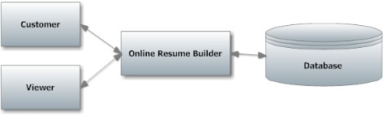

Figure: Implementation

So, the back-end and front-end of the website can be seen below:-

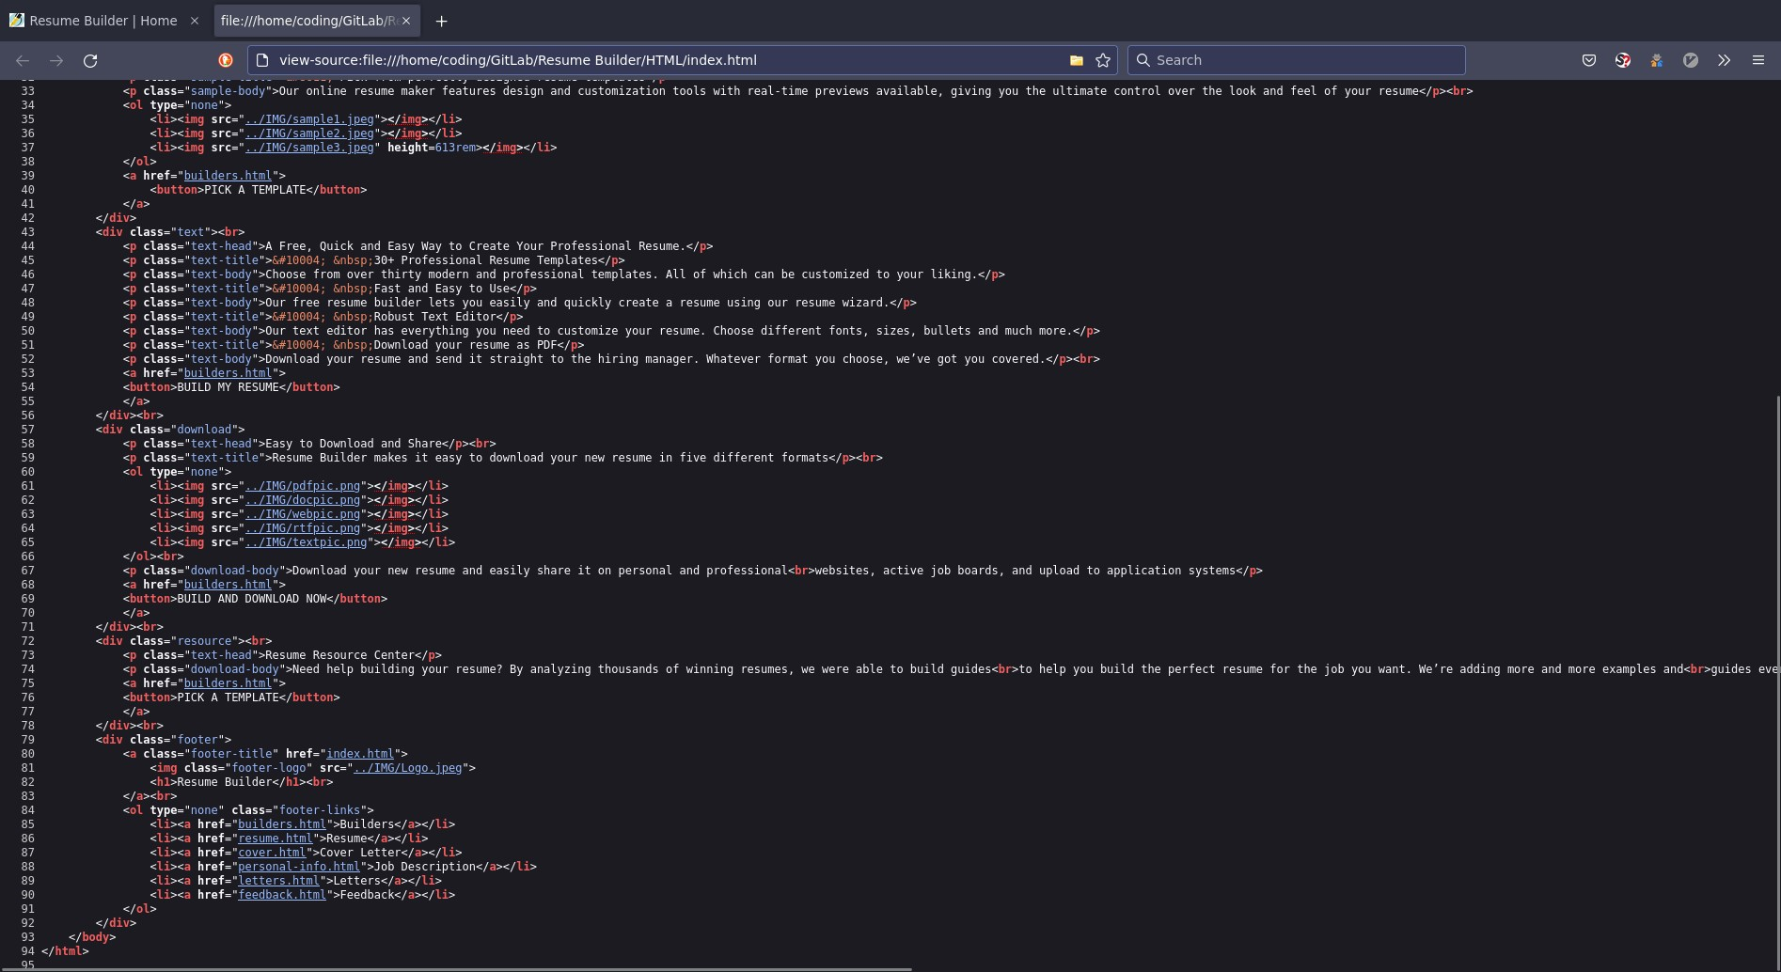

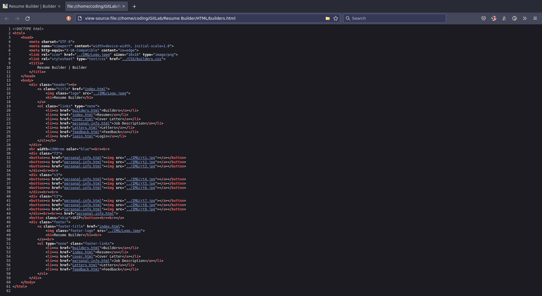







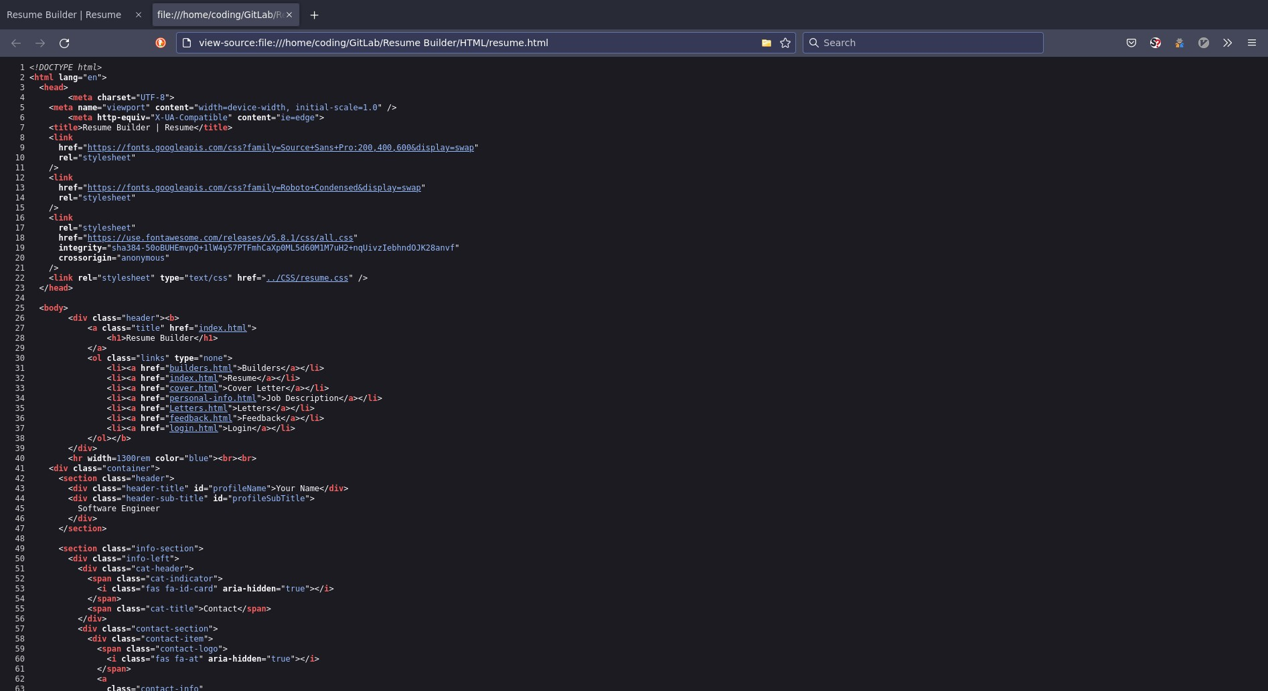

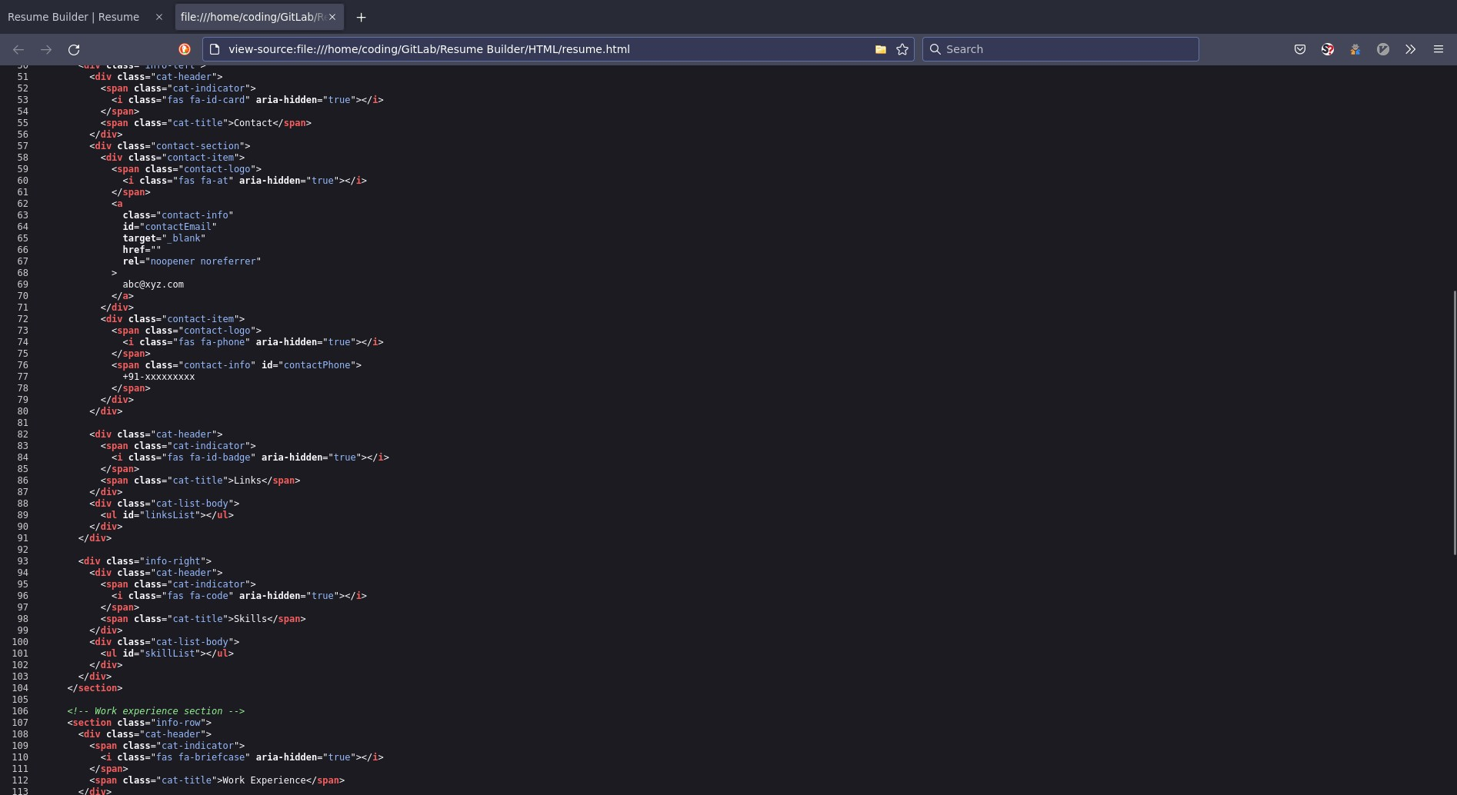

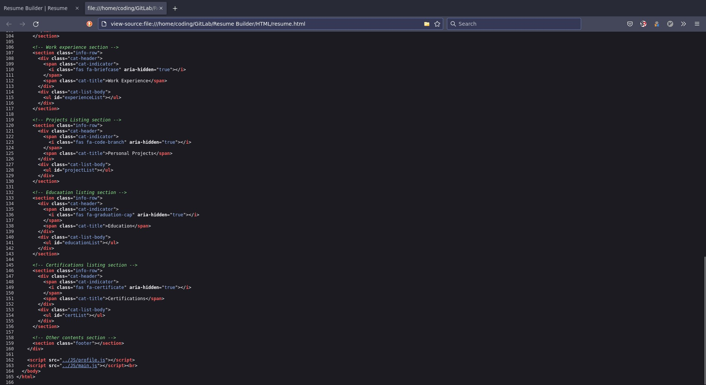

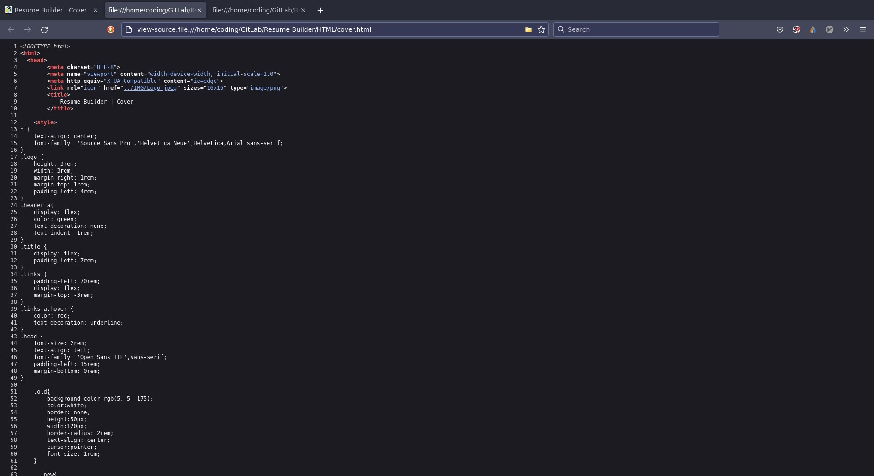

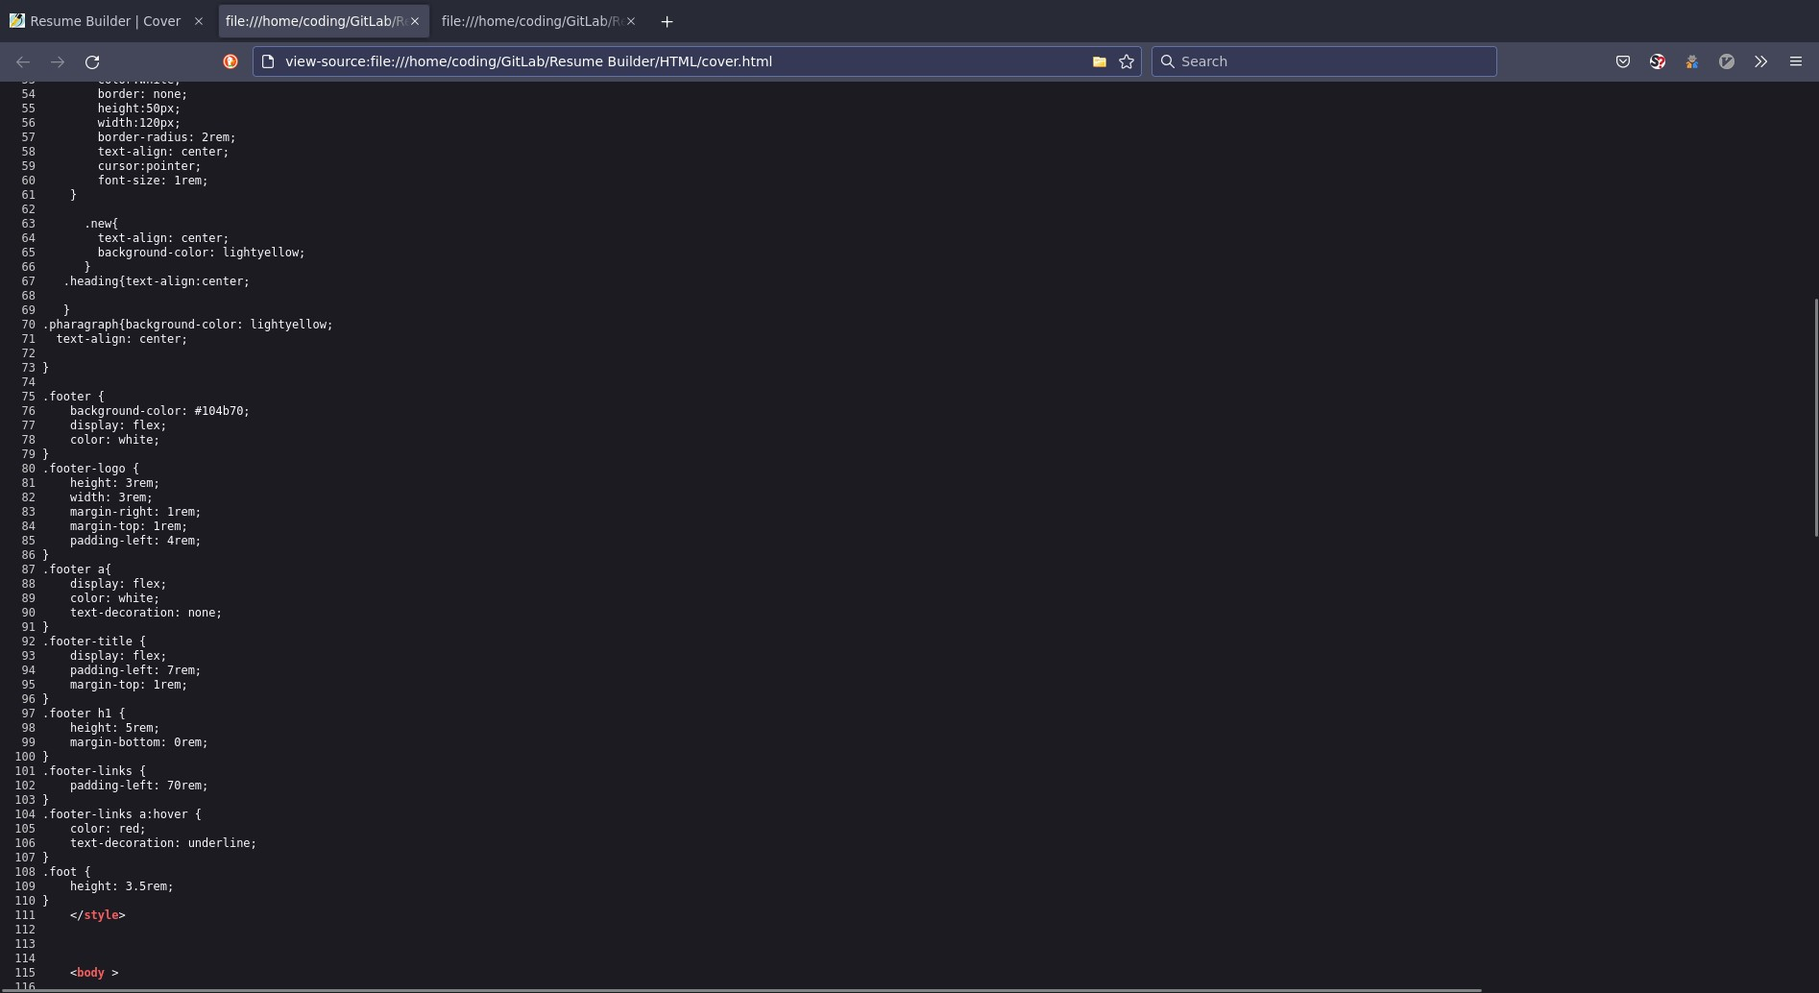

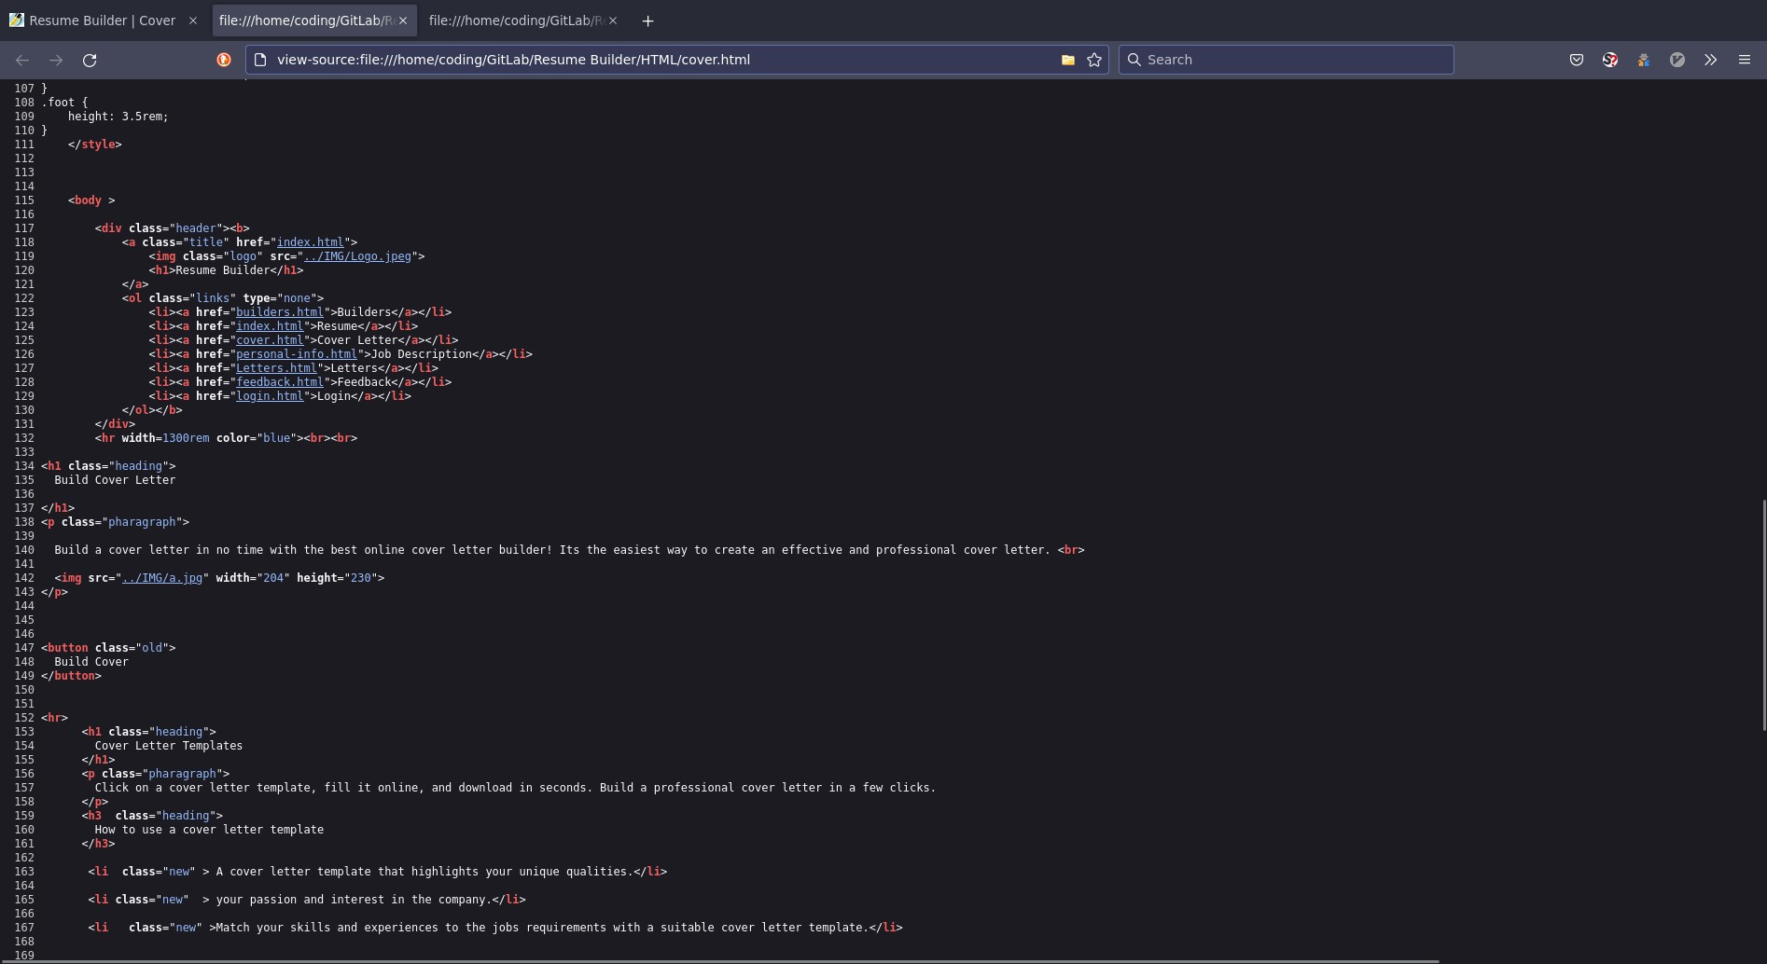

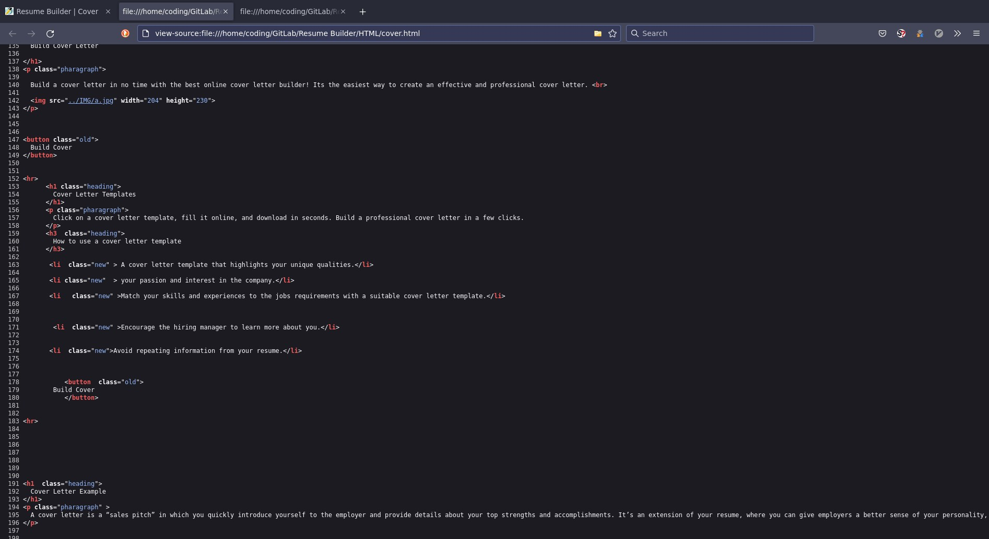

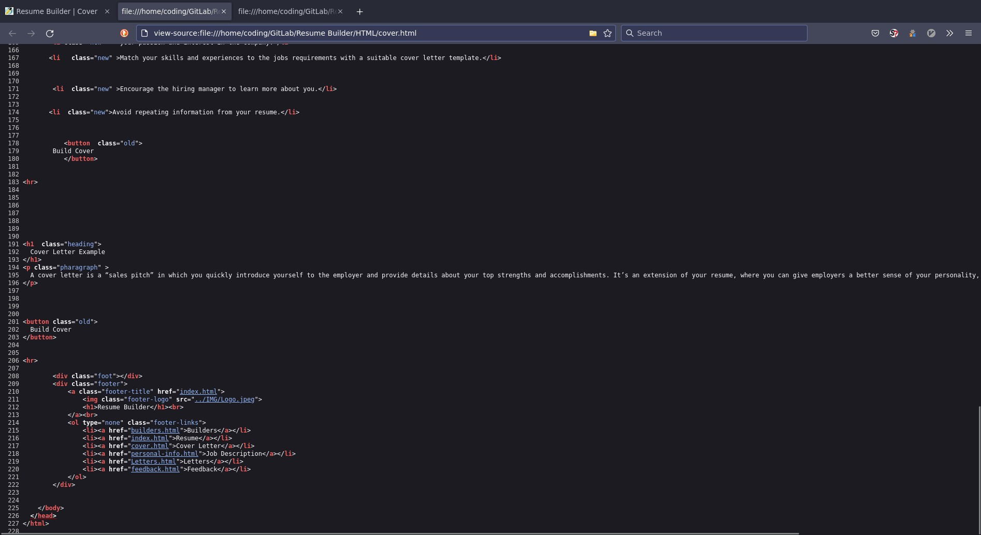

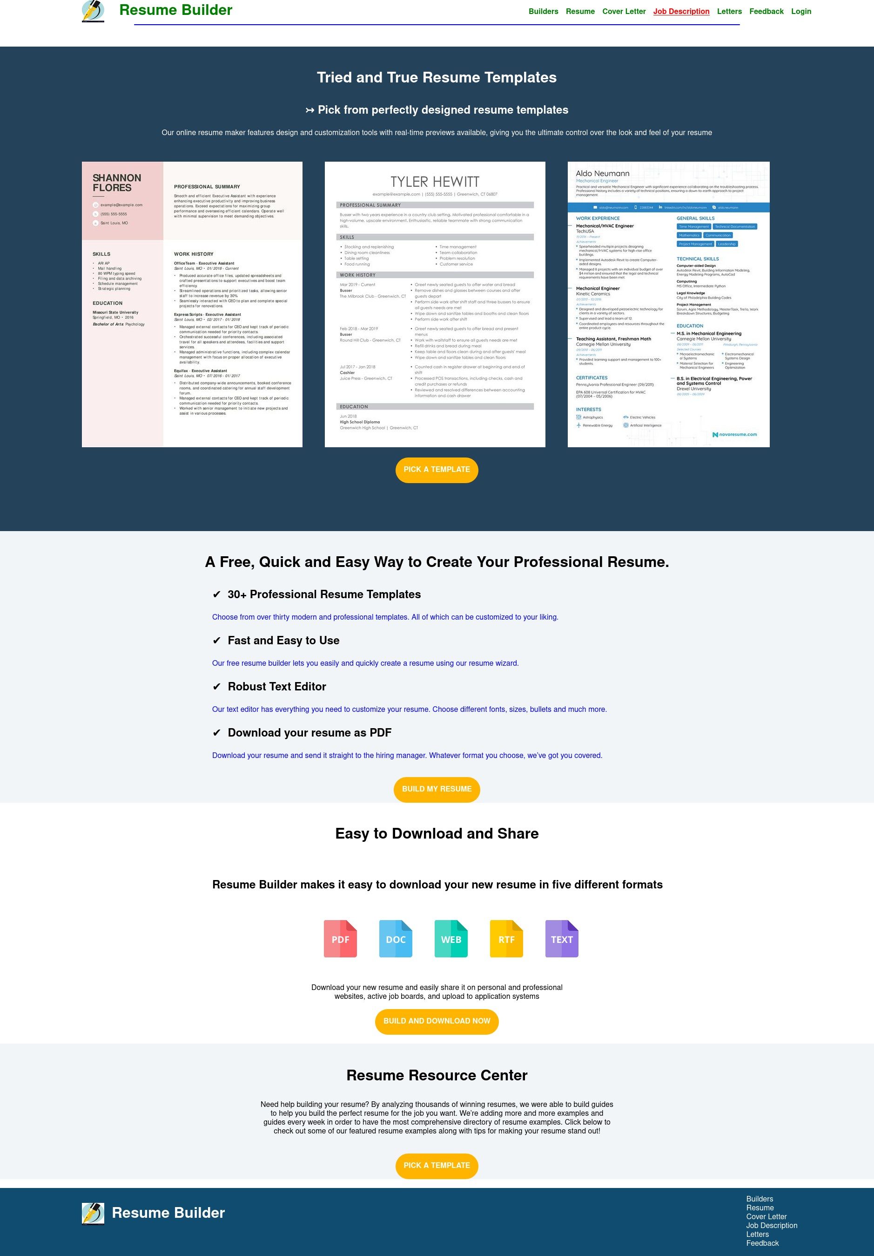

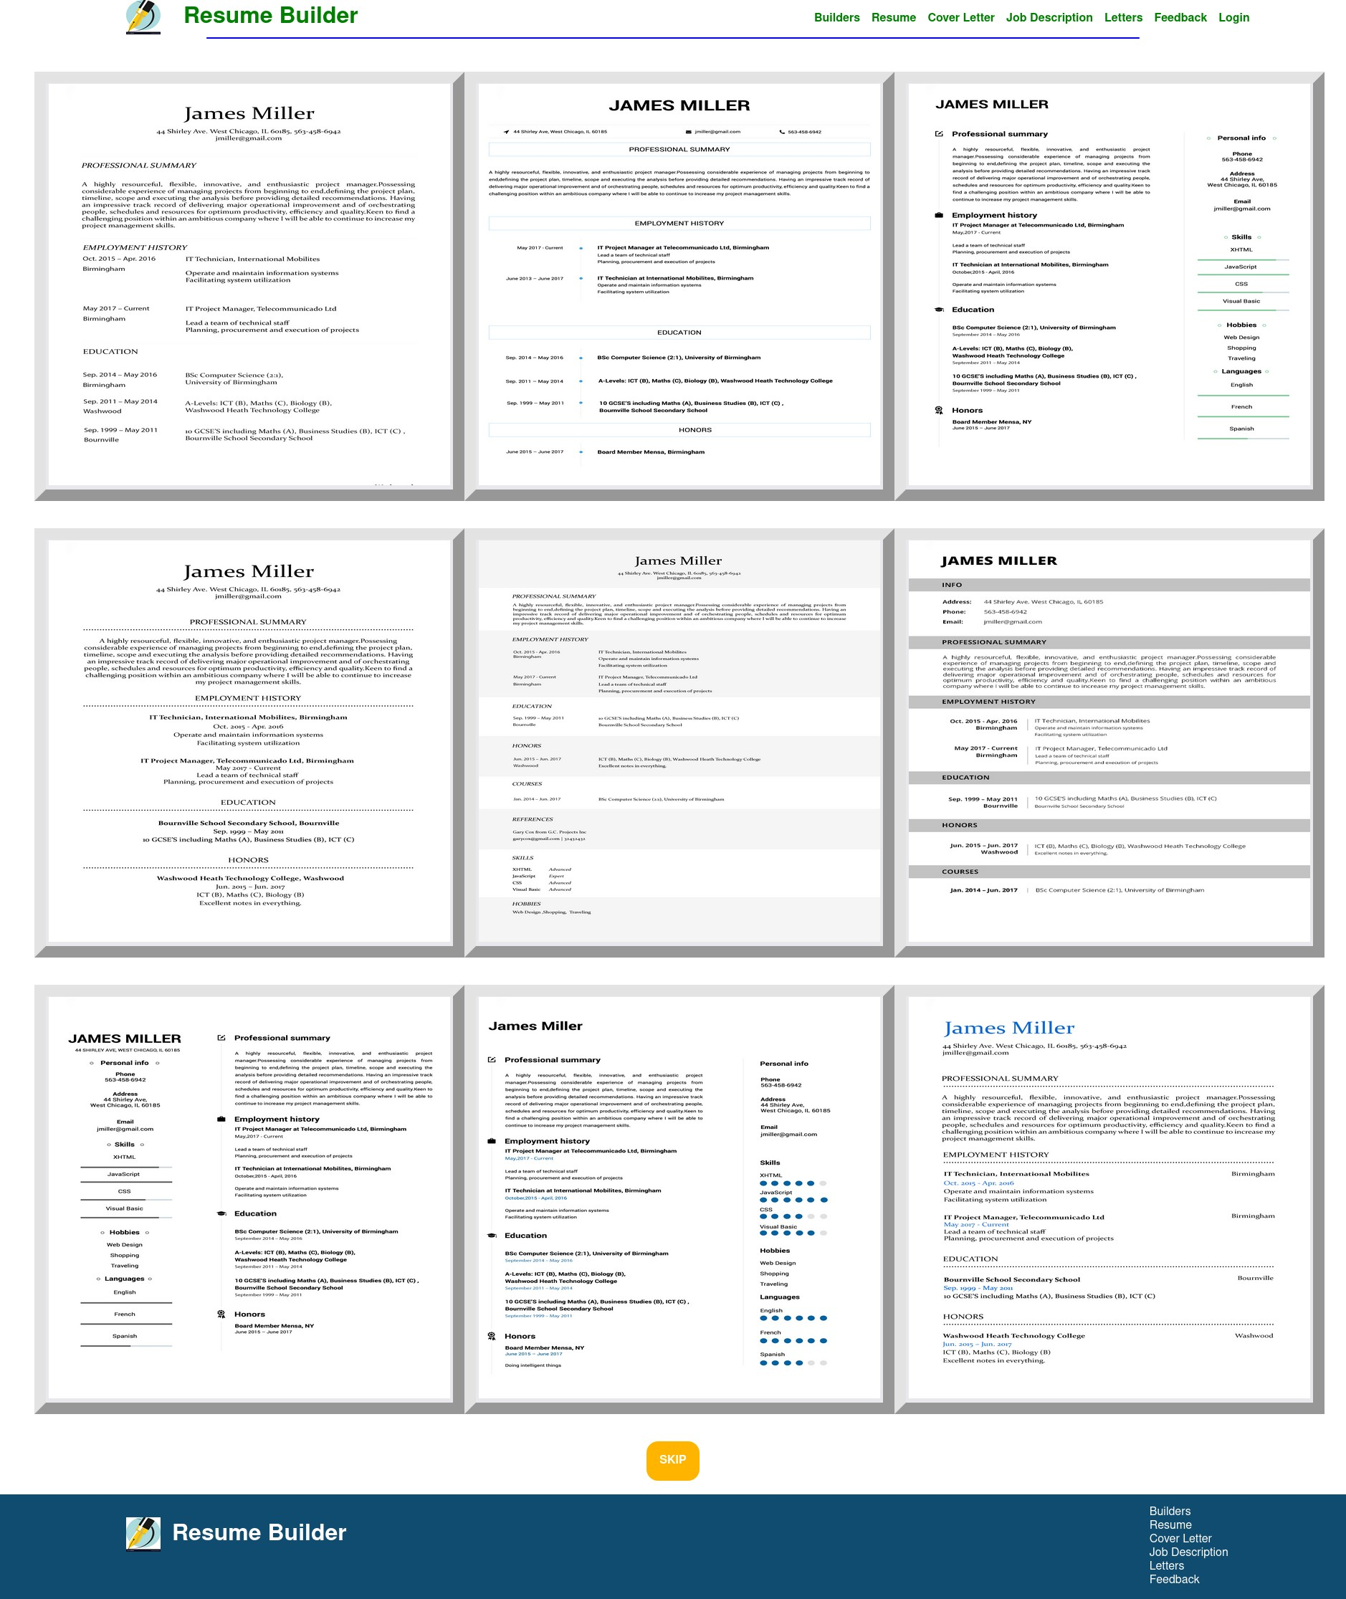

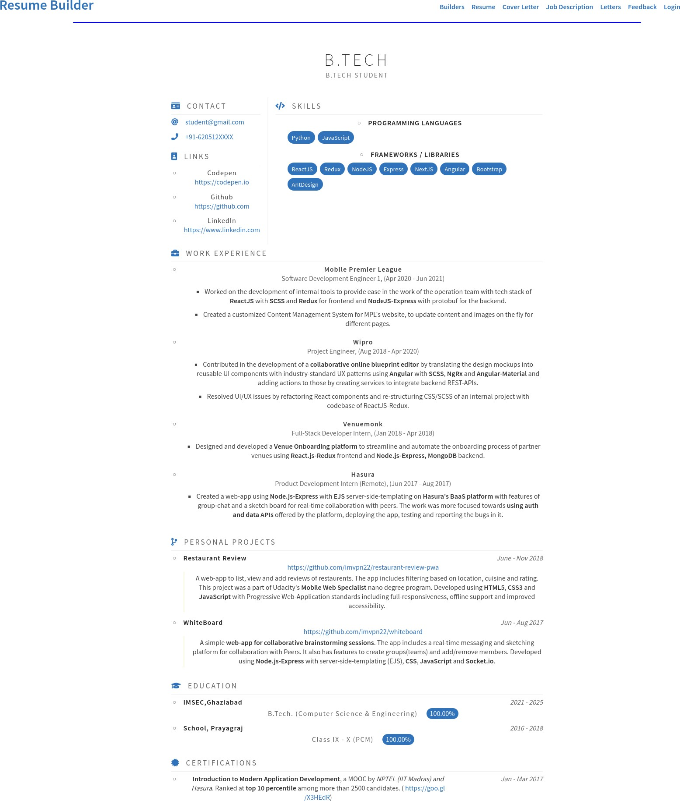

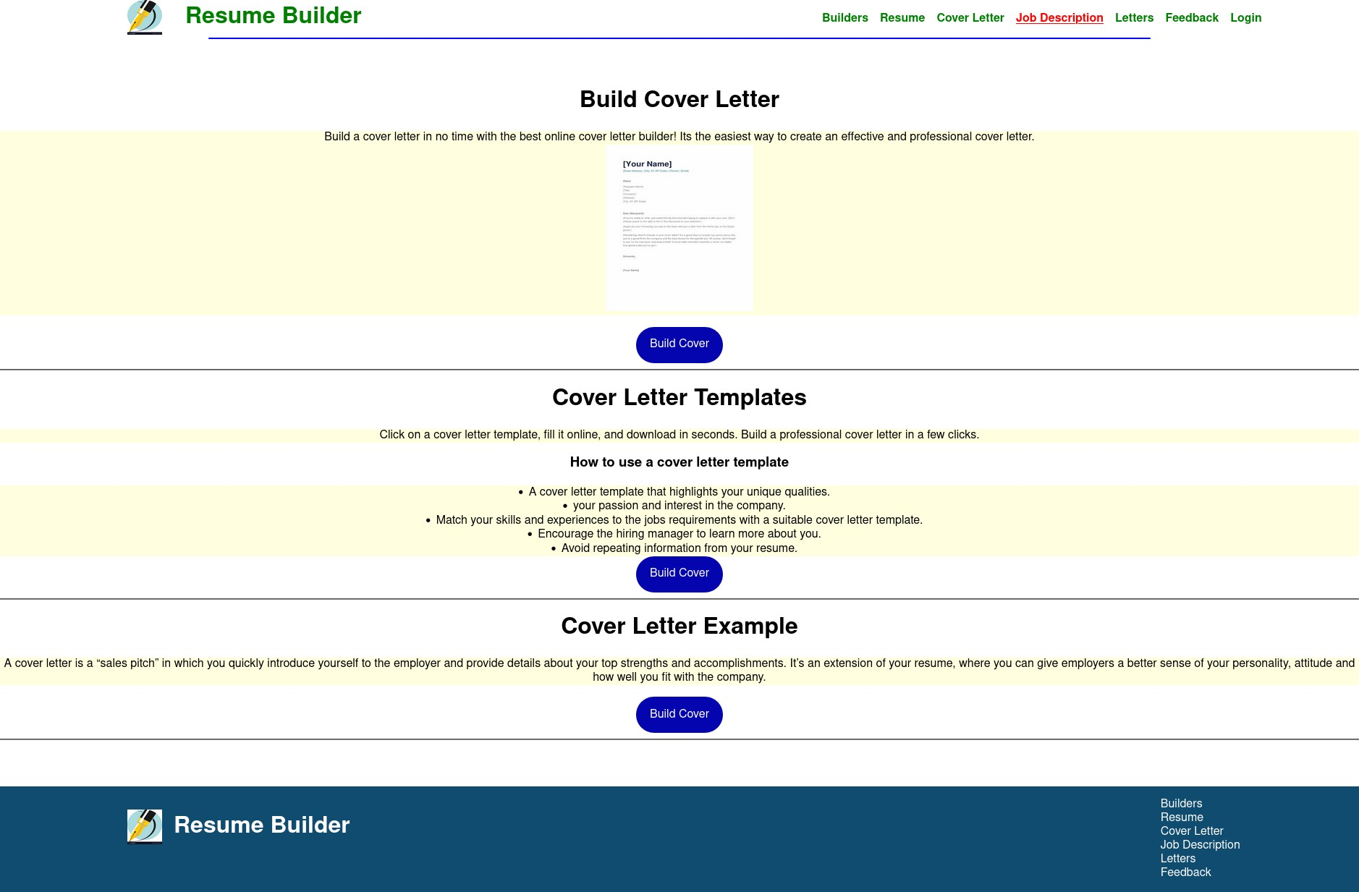

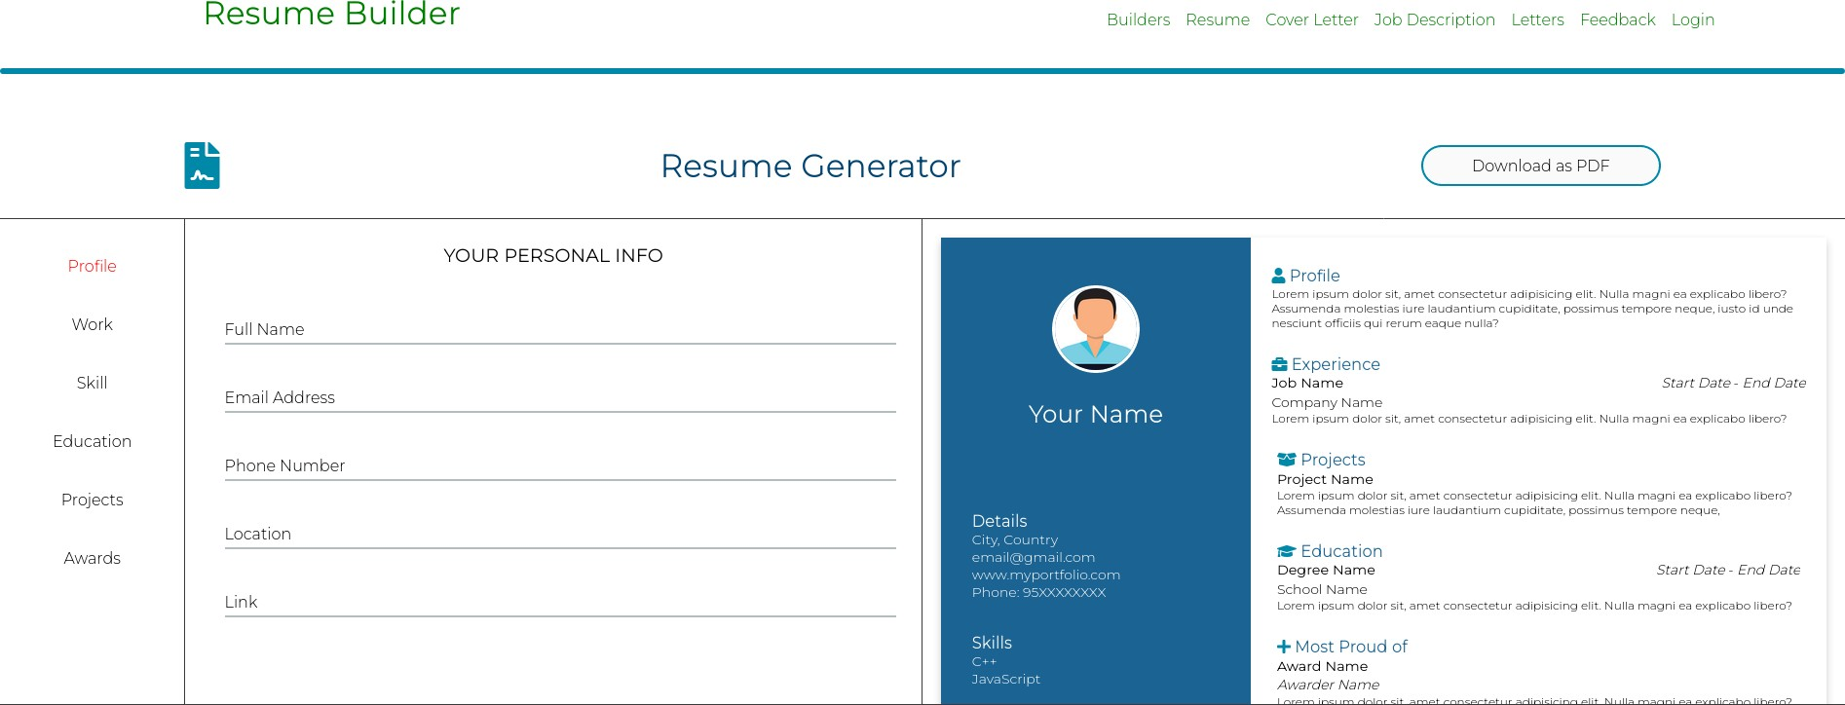

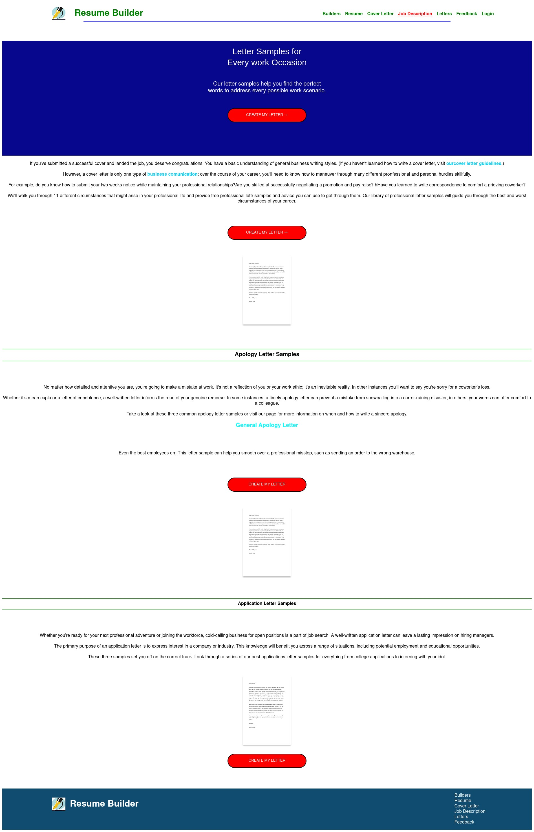

31

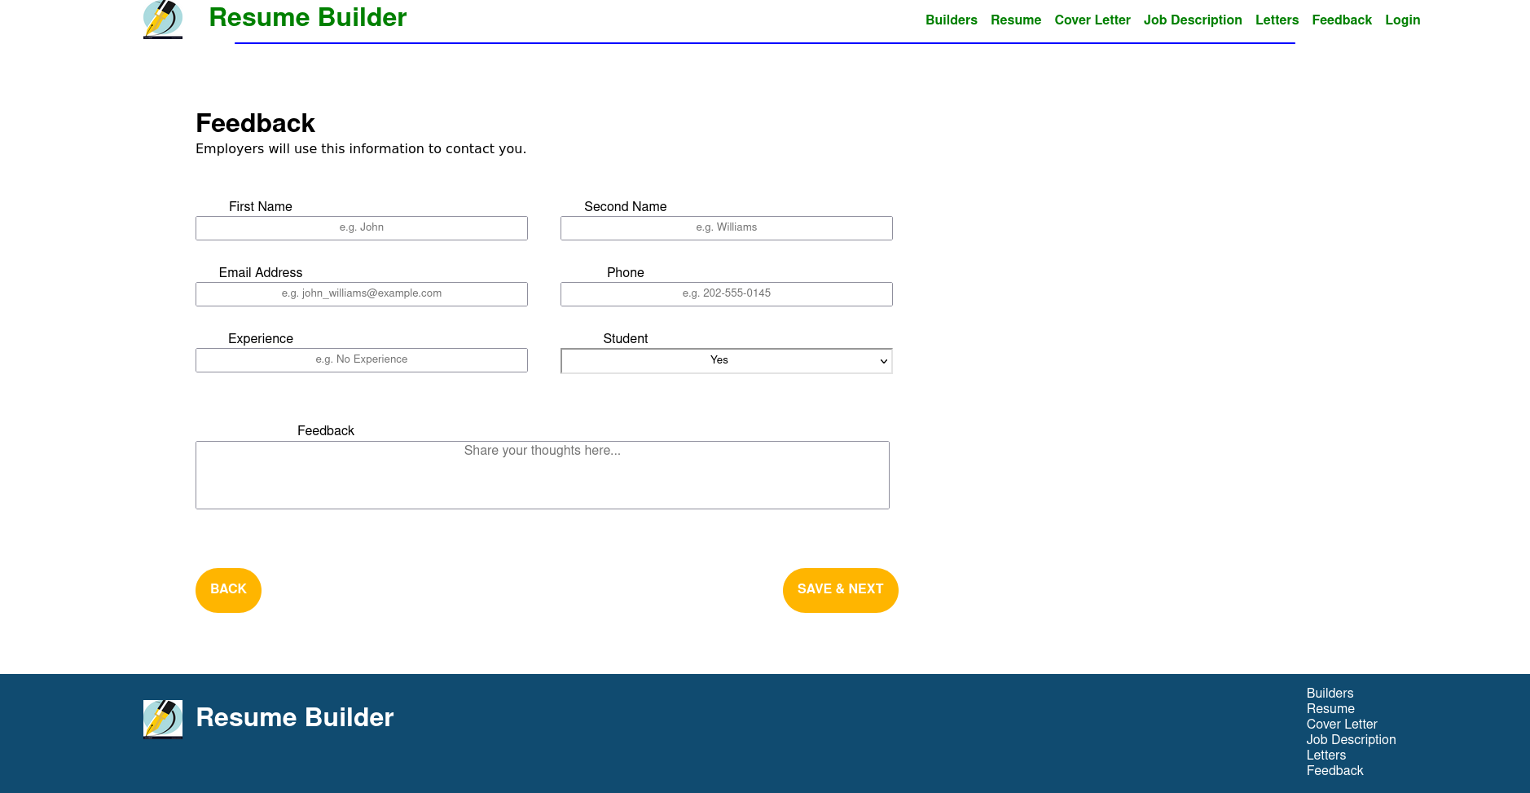



# Chapter 6 CONCLUSION & FUTURE SCOPE

##### Conclusion

Online Resume Builder is for computerizing the working of building resumes. The software takes care of all the requirements of the process and is capable to provide easy and effective storage of information related to customers and resumes that come up to the system. It generates reports for customers & administrators. Provides easy designing tools and other interesting features. The system also provides the facility to contact the customer. This system provides online storage/ updates and retrieval facility. This system promises very less or no paper work and also provides help to customers and viewers. In this system everything is stored electronically so very less amount of paperwork is required and information can be retrieved very easily without searching here and there into registers.

The online resume builder is one of the most fantastic system for the people who are either recently graduated students in their domain or if they don't have enough idea about the resume or don't have enough time to create the resume of good design and patterns then this platform is very productive place for them .ARB(analytical re resume builder)will analyze and give the required output of top trending technology with proper proof of

data ,graphs and statistics. The student can analyze the material and course which they can option for which will be more useful for them in their placements and future it will be a clear path and guide which will make it decision and much more easy and effective there will be a less chance of regretting and wasting the time of different courses which are not worth.

##### Future Scope

Each project should pay close attention to future development, because it contains the systems most recent feature. It lessens software issues and defects. It develops a close relationship with customers based on their comments or preferences. Developer will incorporate certain dynamic elements that are briefly described below into my restaurant management system Reporting Module with real time mechanism. As our future work for the Online Resume Builder website we will be adding back-end to it and make the login page working as those who want to store their information for further use or to update things in future. And even we will be adding few more methods to download the resume like in word formate and etc. We will even add feature to give suggestions to the user while filling their resume in experience section and others too.

# REFERENCES

Some websites from which we have taken help from are also listed below :-

* HTML: Complete Reference
  + [www.w3schools.com](http://www.w3schools.com/)
  + [www.emurse.com](http://www.emurse.com/)

Various e-books and tutorials provided on Internet by these websites too :-

* [www.wikipedia.org](http://www.wikipedia.org/)
* [www.webreference.com](http://www.webreference.com/)
* [www.dynamicajax.com](http://www.dynamicajax.com/)
* [www.webdesign.org](http://www.webdesign.org/)
* [www.csstutorial.net](http://www.csstutorial.net/)
* [www.photoshopsupport.com](http://www.photoshopsupport.com/)
* [www.learn-sql-tutorial.com](http://www.learn-sql-tutorial.com/)
* [www.learn-xml-tutorial.com](http://www.learn-xml-tutorial.com/)